CALL FOR PROPOSAL

FOR A TRAINING COURSE
“Creating Youth in the World” Donetsk Ukraine
07th may to 15th may 2013
We are urgently looking for partners according to the project conditions for the deadline of 1st feb. 2013
IDEA
The “Creating Youth in the World ” bring 2 unemployed youthleaders each organisation including new users of EU candidates countries within the Youth programme and others who never used before: Ukraine, Azerbaijan, Georgia, Spain, Portugal, Slovenia, Turkey, Romania, Bulgaria, Moldova, Sweden, Belgium, Russia and Belarus.
14 countries organisations together from new to old users of the Youth programme, where all participants have been long term unemployed and need coaching to restart life and why not starting a project? They have never ever or have no experience of managing a youth project get together in Ukraine and learn, create and get education how to implant, start, develop around a youth project with volunteers. Further more we invite countries that are from big big economic crisis in EU such as Portugal & Spain to exchange their experience of life by dealing with their life.
-The methodology in the training course is based on values of non-formal education, intercultural, individual, experiential and experience-based learning.
-The methodology to be used is learners-centered: encouraging active involvement of the participants, creative and critical thinking and the multiplying approach through promoting the idea of international co-operation in the field of youth work.

-The working methods are diverse and planned to meet the needs and expectations of the participants as well as to lead towards of the aim and objectives of the project.

The basic contemplated working methods are as follows:
  - Group-building exercises,
  - Lectures, presentations,
  - Group discussions,
  - Role-plays,
  - Simulation games,
  - Site visits,
  - Questionnaires and evaluation forms,
  - Reflection groups.

Participants
2 LONG TERM UNEMPLOYED youth leaders / youngsters per country from 18 years old and up
Countries:
Ukraine, Azerbaijan, Georgia, Spain, Portugal, Italy, Hungary, Turkey, Romania, Moldova, Sweden, Belgium, Armenia, Russia and Belarus.
-The training course shall host 28 or 32 participants hailing from Non Governmental Organizations from Europe and Asia,
-Believing in equal opportunities, VUFE “We Youth For Europe Association” respects gender balance between males and females.

In principle, contact persons are reminded that their respective delegations should be young people aged between 18 up / …years of age. Should you have a problem in selecting participants please inform us.

Venue
Donetsk Ukraine

Dates
Travel days 07th to 15th may 2013 (VUFE ass. Has the right to change the dates)

Programme of Activities
We are providing you with a programme of activities. We ask you to make this available to the delegate/s attending the event. Delegates are expected to be present for all sessions and those not present will forfeit reimbursement.
The draft programme is attached.

Deadline
To sent the PartIII agreement in digital form in word by email latest 1st December 2012

Trainers
this project is administrated by We Youth For Europe association in Sollefteå Sweden www.vufe.org
the trainers will be hold by The Knot ass. In Brussels Belgium
for more information look into here: http://www.theknotweb.eu

PRACTICALITIES

Travel
Reimbursement of Travel

Travel expenses are 70% reimbursed (on presentation of the relevant receipts) if you travel in the cheapest way, the payment will be made by bank transfer, NOTE! No cash reimbursement only by bank transfer.
Upon arrival in Ukraine participants shall be able to photocopy their travel tickets but we want you to photocopy them already in your country before using in the travel so we have the full copy of the original ticket and official receipts (2 copies). Once proof of travel cost is collected and the hosts will reimburse 70% of the total travel cost.
- No business class tickets, taxi or flights that are more cheap to go by
train, The NA do not accept such receipts as they not in the programme
- OBS. That if you not have a receipt we cannot cover your travels at all.
You must take the transport that has receipts.
Such as taxi drives that have no invoice – OBS. You will not get
reimbursement for that!

Observe that the reimbursement for EU countries will only be made 3 months after the activities of the program because the national agency reimburses the grant only after the final report.

- Together with the preliminary agreement Part III, we also need to know your whole estimated draft travel expenses and the name of the city that you travel including the mean of transport (train, car, bus, and plane).
- Participants are expected in Ukraine 08th may 2013 and depart the following 15th may 2013. This means that participants are hosted for 7 nights and that contact persons are to book participants’ travel tickets on these dates early to avoid full flights. The travel tickets booked should be notified to us as soon as possible and registered on the delegates registration form (will be sent to you after approval of the project).

- When you get a offer of the travel flight are recommended as they are the cheapest you shall contact the project coordinator to check if the price is reasonable and if maybe in Sweden we can buy cheaper flights.

Participation fee:
EU countries: 70 Euro
NO EU-countries or other countries: 20 Euro

Accommodation
Participants will be accommodated at no charge for a maximum of 7 nights on full board basis (breakfast, lunch and dinner) at the youth hostel.

Delegates will be accommodated 2 persons in a room and thus each delegate will be sharing the room. We shall however do our outmost to try to satisfy all your accommodation demands.

Food and Beverages
Since delegates will stay on a Full Board basis and Half Board Basis, all meals shall be covered by the hosts. However, in the case of beverages (both alcoholic and non-alcoholic) delegates are expected to purchase their own. Therefore we recommend that participants have some money available.

Dietary / Health Conditions
If you have any particular dietary restrictions or suffer serious health conditions or allergies, kindly indicate this in the registration form.

Extra Nights
Whilst air companies operate daily flights to a number of destinations, some other destinations only receive flights from Ukraine once or twice a week. This might encourage participants to stay for extra days.

- Also participants may be interested in discovering the Ukraine and stay over for a post-event break. We are therefore encouraging participants to stay for extra days in Ukraine and have made arrangements by themselves. The extra nights are going to be paid by the participants and so be reduced from the Reimbursement because we as organizers are going to pay for all the nights of the participants from 08th to 15th may 2013. As we said extra nights are going to be paid by participants.

If the above reasoning if not satisfactory. You may also search other hotels listed online in internet.

Transfers
Transfers from the airport to youth hostel shall be organized by the hosts and this is why indication of arrival time / flight number is required on the delegates registration form.

Visas: http://www.mfa.gov.ua/mfa/en/509.htm
Delegates requiring an entry VISA to enter Ukraine should inform us in the delegates registration form. If your country is a Member State of the European Union you need no VISA. Outside the European Union, there is a probability that a visa is required so please check with your local authorities. The hosts will send an official invitation letter which participants must then present to the nearest Embassy or Ukraine Consulate – VISA will then be issued. It is required that participants send a copy of the passport together with the delegates’ registration forms.

Insurance
Participants are required to be in possession of a travel insurance policy, since this will not be covered by the hosts. Whilst organizing the event with utmost diligence, the hosts are nonetheless relieved of any obligation or responsibility arising from death, personal injury, illness, theft or any other misfortunate circumstance. Participants are to indicate insurance cover in the delegates registration form, and encouraged to effect such insurance policy as precaution is better than cure!

Currency
Ukraine has its own currency - 1 Euro = 10,7697 Ukraine Hryvnia
Heck it out here: http://www.oanda.com/convert/classic

Registration Desk
Registration desk will be open all day on Monday 08th may 2013. Upon arrival, delegates will sign the official attendance form and then be instructed to the youth hostel Reception. For this purpose the registration desk shall be located in the youth hostel Lobby near the main entrance.

Meetings / Workshops
All plenary meetings / workshops will take place in the empty room Hall. Workshops are going to be held within the different conference rooms that the youth hostel corporate, some of the workshops will be outdoors.

Evening Entertainment
Evening entertainment
We will select a social Entertainment committee (participants themselves)
So prepare to organize yourself a Party ☺

Dress Code
During the launch, participants are encouraged to wear normal appropriate dress code, not official tie no please!!. However during sessions participants are to wear casual, clothes.

Weather Conditions
The temperature in Ukraine at this time of year is still pretty cold and the more adventurous people may wish to even take a swim in a pool. You may check latest weather conditions on internet.

Working Language
Delegates should also be conversant in English, since all plenaries, presentations, workshops, games and meetings will be delivered in this language. Participants shall speak GOOD English.

To bring with you
We kindly ask participants for bringing materials about their organisations
- Some discs with the national music
- Inform. Materials for multimedia presentation, we will not show any PowerPoint’s presentations from but you can show to others in your free time.
- Flags of your countries
- Comfortable shoes for sport games both inside and outside
- Comfortable clothes for sport, SKI and snow
- a swimming suit
- a big towel for a sauna and Swimming
- Shampoo, soap, tooth paste and brash, etc.
- Individual specific medicines (if it’s really necessary, we have only standard set of medicines)
- Warm sweater
- Ssomething typical from your town, region or country – music, food or drinks☺ – to share with other participants during the intercultural evening will be welcomed!! And of course don’t forget about lots of energy, enthusiasm and curiosity!!
-Big smile!
Or the exhibition you are asked to bring with you everything you think may be useful to present your organisation and promote your activities and projects, such as leaflets, brochures, videos, slides, etc.

WHAT TO DO NEXT:
- Send us the preliminary answer that you are interested in the project.
- Sent Promoter agreement that I sent you, please sent by Word format document the squares that are empty of the attached Partner agreement.
Sent it by email. tony@vufe.org Sent it by normal post.
Tony Vieira, Bivackv. 2, SE 88151 Sollefteå Sweden
- Send us your travel costs in Euros maximum from your home to Donestk Ukraine
- Send us the meaning of transport including name of cities

Special requirements
- When you have some special requirements including food (vegetarian, etc.), please do not hesitate to write to Mr. TONY VIEIRA email: tony@vufe.org

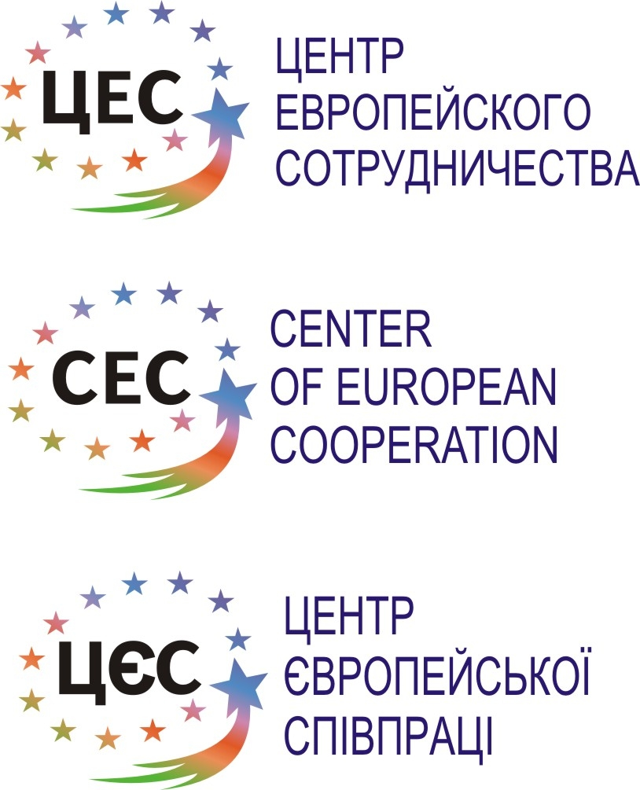
Practicalities contacts
(after the project will be approved, you can contact her):
Host:
Elena Smagliy
Director of the Center of European Cooperation
+3 8 062 210 19 46
www.center-ukraine.org.ua
www.tvoiprava.dn.ua

Manager / Contact:
Manager / contact person for all the practical information about the meeting sent:
Email. tony@vufe.org
Or contact Mr. Tony Vieira
President – We Youth For Europe Association
Youth site. http://www.vufe.org ot www.viunga.nu
Phone office hours 07.00 am – 16.30 pm. +46 620 68 23 12
Cellular. +46 703 46 18 92

Looking forward to host you in Ukraine!
Tony Vieira (Sweden) , Ronald K (Belgium) / Elena Smagliy (Ukraine)/ managers / Trainers
The Knot
Roekensstraat 12
1820 Melsbroek Brussels Belgium
www.theknotweb.eu
